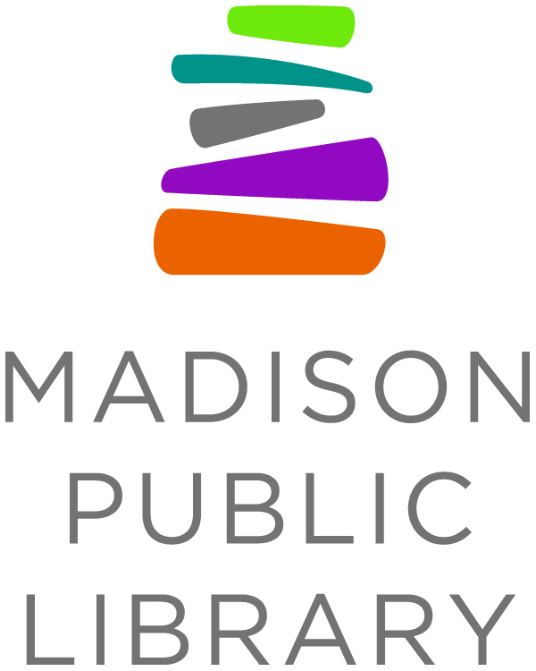

For Immediate Release: June 9, 2020
Media Contact: Tana Elias, Digital Services & Marketing Manager,
Madison Public Library, 608-225-0619, telias@madisonpubliclibrary.org

Madison Public Library Launches ‘We Read’ Program

MADISON, W.I. - We Read is a Madison-wide community celebration of reading - everyone is invited to participate no matter what kind of reading you’re doing! There is no registration to participate, no right or wrong way to read, no pressures or expectations. Instead, we invite you to do whatever reading brings you joy. To be a part of We Read, find something to read that you love, share it with a friend or share it on social media and join in the conversation about your favorite ways to read. It’s that easy.

Madison Public Library reimagined the typical Summer Reading Program in light of community input, an increased focus on removing barriers to the typical visit- and incentive-based programs, and in light of an uncertain reopening date for library buildings and in-person services. “We want to shift the focus from adding more tasks to your summer schedule to instead acknowledging the benefits of the reading that you’re already doing,” said Tammy Ocampo, Youth Services Manager at Madison Public Library. “And perhaps inspire you to try something a little bit different (like reading in a blanket fort or listening to a kids’ podcast together).”

A series of We Read themes was developed to showcase the different ways Madisonians read. Every two weeks a new theme will be introduced for kids, parents, and caregivers to interact with on the Madison Public Library Instagram account (@Madisonpubliclibrary). Illustrator Emily Balsley lends her artistic talent to help inspire readers and introduce each theme. The illustrations depict different ways We Read and include diverse imagery.

WE READ SCHEDULE
- June 8-21 We Read Together / Leemos juntos
- June 22 - July 5 We Read Outside / Leemos afuera
- July 6-19 We Read With Our Ears / Leemos escuchando
- July 20 - August 2 We Read at Bedtime / Leemos antes de dormir
- August 3-16 We Read on Screens / Leemos en una pantalla
- August 17-31 We Read in a Comfy Spot / Leemos en un lugar cómodo

PARTICIPATE IN WE READ
Parents, caregivers, kids and teens can share their recommendations or showcase their favorite books through photos, short videos, poems, artwork, etc. using the #WeReadMadison hashtag and/or liking/sharing/tagging @MadisonPublicLibrary. Follow along with the themes and access free, downloadable content on the website, including posters, an interactive zine and coloring sheets.

Visit madisonpubliclibrary.com/weread to learn more.

About Madison Public Library
Madison Public Library’s tradition of promoting education, literacy and community involvement has enriched the City of Madison for more than 140 years. Visit the library online at www.madisonpubliclibrary.org, madisonpubliclibrary on Facebook, @madisonlibrary on Twitter, or @madisonpubliclibrary on Instagram.

