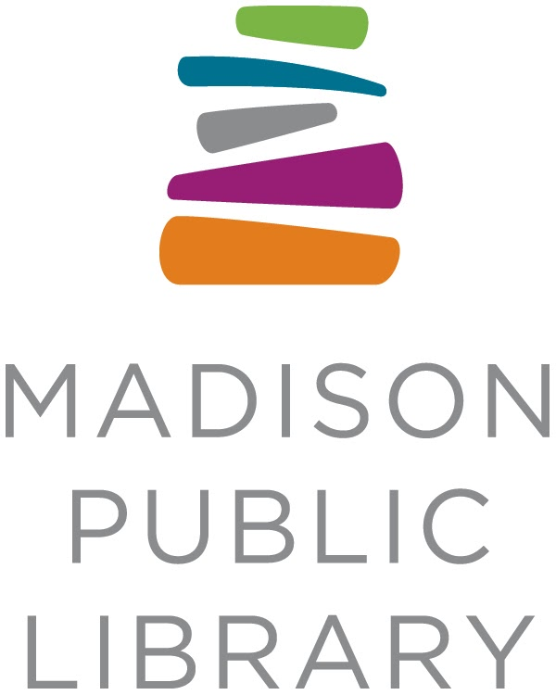
For Immediate Release: July 23, 2021
Contact: Liz Boyd, Marketing Specialist, Madison Public Library, 773-571-2742, eboyd@madisonpubliclibrary.org

Pinney Library Welcomes Its First Artist-in-Residence

MADISON, WI -- The Bubbler at Madison Public Library announces artist Maria Amalia Wood as the inaugural artist-in-residence at the Pinney Studio within the new Pinney Library. Amalia Wood will be in residence through January 2022 and works with textiles, paper-making, and community-focused storytelling. Her current project involves exploring journeys: she'll be asking participants to engage by exploring feelings, place, memories, and beliefs in lots of hands-on ways. Those willing to share their own immigrant journeys are especially encouraged to participate. Madisonians can visit Amalia Wood during open studio hours on Thursdays from 10:30 a.m. - 12:30 p.m at the Pinney Library.

Pinney Library opened to the public briefly in March 2020 with the new artist space from the Bubbler set to begin hosting artists-in-residence, but the COVID-19 pandemic meant that the library (and the studio space) wouldn’t reach their full potential until over a year later.

"We see the Pinney Studio as a physical extension of the Bubbler mindset. A dedicated space to get messy, explore 'stories' differently, and learn alongside artists and experts from our own community,” said Bubbler Program Assistant Carlee Latimer. “While the use of this room will shift and change based on the needs of the Pinney community, we're incredibly lucky to hit the ground running with such an extraordinary and community-focused artist like Maria."

Through open studio hours and collaboration with different neighborhood groups and organizations, Amalia Wood asks participants to create alongside her this summer. In September, October and November, Amalia Wood will work on putting all of the collaborative pieces together and resulting in a public art piece that will be hung permanently at the Pinney Library in December.

When visiting the Pinney Studio this summer, you will see multiple projects that help explore the overarching theme of journeys. Projects include:
- An emotional journey through feelings captured on the windows of the Pinney Studio
- A physical journey through place while exploring visual and written storytelling of remembered places
- A mental journey through memory within sunsets and handmade paper collages
- An inner journey through self by exploring beliefs and biases within us
Having more than 12 years of experience working with craft communities in Latin America in product development, Amalia Wood’s art practice is built on a foundation that includes a commitment to the highest standards of craftsmanship in making, intellectual curiosity, and constant searching for authenticity and relevance.
From a very young age Maria Amalia participated in community projects with her parents, observing, listening, learning from their workshops and becoming conscious of the importance of the participation of women and minority groups in processes of social change. Additionally Amalia Wood is working alongside two teen interns, Itzayana Miranda-Pesina and Noa Delgado-Lopez, who are being mentored in the collaborative and traditional process of papermaking. Amalia Wood continues to be passionate about using art and design as a tool for social justice.

This opportunity is supported by the Friends of Pinney Library. Learn more online at: http://madisonbubbler.org/pinney-studio-artist-in-residence

Open Studio Hours: Thursdays, 10:30 a.m. - 12:30 p.m.
Community members of all ages are invited to drop in, meet Maria and her teen interns, and participate in various making activities.
Additional Workshops:
Maria Amalia Wood will all be facilitating other workshops in the community in the coming months:
- August 12 at Warner Park from 3-5p ~ North Side Block Party ~ Pulp painting
- August 14 at Berkley Park from 12p -2p ~ BYAYA Family Fun Day ~ Pulp painting
Other closed, targeted workshops include working with East Madison Community Center at Hawthorne Library, Lighthouse School, and a network of Spanish-speaking care providers at Pinney Library.
About the Artist: Maria Amalia Wood
Maria Amalia, she/her (@mariaamaliawood on Instagram) holds a bachelor’s degree in General Art with a minor in Visual Communications from Judson University and an MFA in Textile Art and Design from the University of Wisconsin-Madison. For the past four years, Maria Amalia has been creating paper and textile objects that refer to memories of lived experiences. While constantly honing her ability to intelligently compose, Maria Amalia has developed a process for manipulating the wet pulp that allows her to work freely, creating marks and passages that evolve organically through a repetitive process of building an image with layered, ripped, painted, and collaged forms resulting in complex surfaces that carry rich color and texture passages.
About the Bubbler at Madison Public Library
The Bubbler’s hands-on workshops, performances, and events introduce participants to a variety of local experts who share their talent and passion for art, design, and maker culture. For more information, visit madisonbubbler.org, Madison Bubbler on Facebook, or @madisonbubbler on Instagram.

About Madison Public Library
The Madison Public Library's tradition of promoting education, literacy, and community involvement has enriched the City of Madison for more than 145 years. All 9 library locations are currently open for in-person browsing, pickup-up of holds, computer service and in-person reference.

