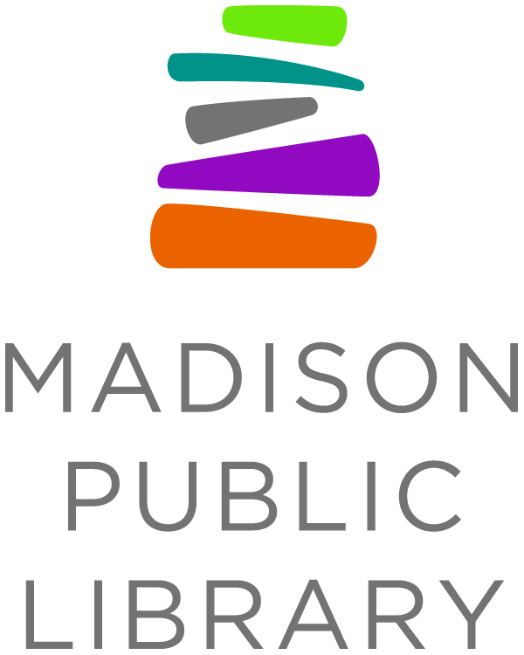

For Immediate Release: September 11, 2020
Media Contact: Tana Elias, Digital Services & Marketing Manager,
Madison Public Library, 608-225-0619, telias@madisonpubliclibrary.org

Complete the Census at Dream Bus Stops September 14-18

Madison, W.I. - Madison Public Library is partnering with the Census Bureau to encourage Madisonians to fill out the 2020 Census. The Census Bureau will have staff available as part of their Mobile Questionnaire Assistance outreach to work alongside librarians at Dream Bus stops from September 14-18, 2020 to help people fill out the Census. Spanish and Hmong speakers will be on hand at each location to assist with translation, as needed.

Dream Bus stops are determined with community input for locations that may experience transportation and access barriers; many of these areas coincide with lower self-response rate areas for the Census. The Census Bureau’s Be Counted week initiative is an effort to give people in these communities an easy way to fill out the Census through a service they are already familiar with.

Census workers will be present at the following Dream Bus locations from September 14-18, 2020:

Monday, September 14
Tree Lane
7702 Tree Ln
12:00-12:45pm

The Crossings
1128 Morraine View Dr
1:00-2:00pm

ReNew
6723 Schroeder Rd
2:15-3:15pm

Tuesday, September 15
Leopold Elementary
2602 Post Rd
11:00am-12:00pm

Bridge-Lakepoint-Waunona
1917 Lake Point Dr
12:15-1:15pm

Wednesday, September 16
Mendota Elementary
4002 School Rd
1:00-2:00pm

Kennedy Heights Community Center
199 Kennedy Heights
2:15-3:15pm

Oak Park Terrace
571 Banding Ln
3:30-4:00pm

Thursday, September 17
Sandburg Elementary
4114 Donald Dr
11:30am-12:00pm

Vandenburg Heights
1020 Vandenburg St, Sun Prairie
12:45-1:15pm

East Madison Community Center
8 Straubel Ct
2:00-2:30pm

Friday, September 18
Allied Drive Learning Center
2237 Allied Dr
1:00-1:45pm

Owl Creek Park
23 Horned Owl Dr
2:15-3:00pm

The Dream Bus is a mobile library that visits a dozen locations throughout the Madison area five days a week year round. At the Dream Bus, patrons can get a library card, browse and check out materials, return items, place and pick up holds, and use the free WiFi. Madison Public Library, in partnership with Dane County Library Service and Madison Public Library Foundation, recognized that many Madison-area communities experienced barriers to accessing library services. The Dream Bus is a joint effort by all three organizations to alleviate those barriers. Learn more about the Dream Bus at dreambus.org.

About Madison Public Library
Madison Public Library’s tradition of promoting education, literacy and community involvement has enriched the City of Madison for more than 140 years. Visit the library online at www.madisonpubliclibrary.org, madisonpubliclibrary on Facebook, @madisonlibrary on Twitter, or @madisonpubliclibrary on Instagram.

