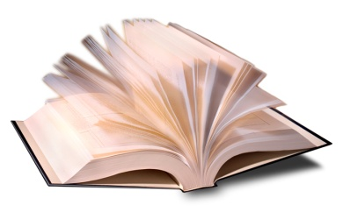

## The Madison Senior Center

Invites you to

# ***Meet the Author***

A Series of Author Talks about Books and Writing

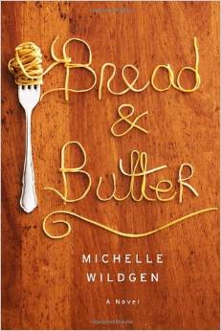

Tuesday, May 12 at 1 pm

**Michelle Wildgen**

***Bread and Butter***

Britt and Leo spent ten years running the best restaurant in their small Pennsylvania town. But when their younger brother, Harry, opens up a hip little joint of his own, everyone’s thrown off kilter. Filled with hilarious insider detail about the seedy bar, ***Bread and Butter*** is both an incisive novel of family and a gleeful romp through the inner workings of restaurant kitchens.



Madison Senior Center

330 W Mifflin Street

Madison, WI 53703

Phone: (608) -266-6581