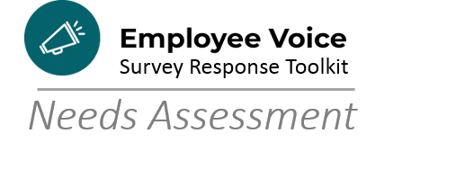

Reflection Questions for Managers, Supervisors, Department and Division Heads

- Was there anything surprising for you in the data?

- Which goals/needs give you the most anxiety?

- Who, on your team, can you tap into for advice and expertise?

- Who, within your professional circle, can you tap into for advice and expertise?

- What areas do you think you’ll need help with?

- Which HR groups can provide you with support?
  - HR/OD
  - HR Analysts
  - HR Labor Relations

- Which Performance Excellence Team Members/Committees can provide you with support?
  - Voice of the Customer
  - Voice of the Process
  - Data Management
  - Line of Sight
  - Leadership Team

