Instructor/Facilitator + Moderator: Roles and Guidance

Facilitator: Zoom Host | Moderator: Zoom Co-Host | Zoom Troubleshooting
General responsibilities:  - Keep focus on the learner  - Create an inclusive learning space  - Build learner confidence  Tasks:  - Welcome, Introductions, Group Agreements  - Keeps flow of agenda  - Reviews relevant session protocol  - Makes announcements & reminders  - Engages audience  Closes out session | General Responsibilities:  - Allow the Facilitator to keep focus on the learner by attending to Chat (Polls, and Breakouts)  - Help maintain an inclusive learning space  - Support learners  Tasks:  - Admits Participants to the session  - Monitors Chat  - Verbalizes questions from the Chat to the Facilitator  - Calls on participants when appropriate  - Assists with minor Zoom troubleshooting  If experienced . . .  - Launches Polls & Breakout Rooms  - Copy/paste to Chat:  - URLs for resources  - Discussion questions  - Instructions  - Evaluation link | Audio or video not working  - Log out and log in again  - Be sure VPN is off  - Check headset or camera settings in Control Panel  Audio or video cutting out  - Turn off VPN  - Check Wifi strength  - Turn off video (to preserve bandwidth)  - Log out and log in again  Email: info@zoom.com  Zoom Support: 888-799-9666  Zoom Support Website: https://support.zoom.us/hc/en-us
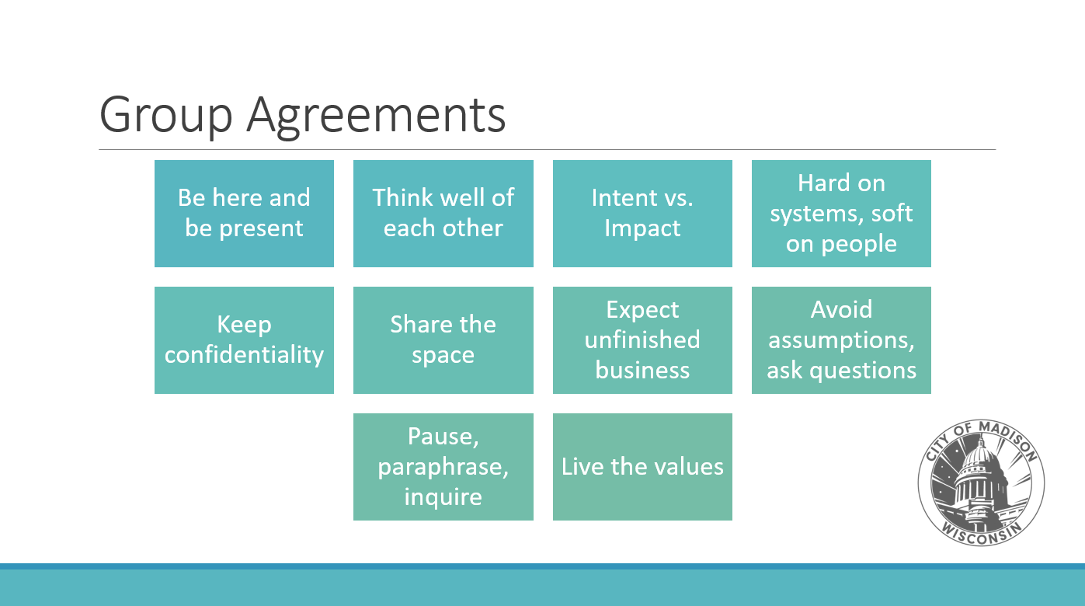
What to do when …Troubleshooting 101

System Technical Challenges
Ex. Slow or disrupted audio/video
- Facilitator will address system issues and provide instructions
- Moderator will assist by using Chat
- Moderator will be the backup facilitator and will have lesson plan handy in case of technical difficulties

Bad Netiquette
Ex. Background noise from a microphone left on
- Facilitator will address with individuals or turn off all mics as needed
- Moderator may remind the group of general netiquette (spoken during a break or via Chat)
Ex. Distracting video behaviors
- Facilitator will remind group to turn off video if they are driving, moving around with camera, talking on the phone, using other devices, other disruptive behaviors
- Moderator may remind the group of general netiquette (spoken during a break or via Chat)

Clarification
Ex. Confused participants
- Moderator will ask the Facilitator to repeat instructions or ask the group to use the Raise Hand feature (in Participant Panel) to ask clarifying questions
- EXAMPLE SCRIPT: “Excuse me [Name] we have a few questions about instructions. Can you please repeat one more time.”
Ex. Unengaged participants
- Moderator may ask distracting participants to turn off their mics or videos
- Moderator may turn off the video or mic of a participant if the noise or video is excessive, disrespectful, or in egregious violation of the group agreements

Inclusive Learning Space Violations
Ex. Someone is violating a group agreement (e.g., not sharing space, not fully present)
- Facilitator will 1st make a general announcement to the audience about our norms.
EXAMPLE SCRIPT: “Let’s hear from someone we haven’t heard from today, remembering that Share the Space is one of our group agreements.”
EXAMPLE SCRIPT: “Friendly reminder of our group agreement to Share the Space”
- Facilitator can call on a friendly name and ask for new voice & new perspective
- Moderator may elect to send a private message to participant if behavior is excessive
Ex. Misgendering or gendered language
- Facilitator will remind the group that “we welcome all people, not just men and women”
- Moderator may remind the group with friendly reminders that examples or situations apply to all genders, not just men and women
- NOTE: If you make a mistake by using an incorrect name or pronouns, apologize and commit to doing better next time. Use the correct name or pronouns, and move on. There is no need to continuously apologize or “feel bad” about your mistake. If someone corrected you, thank them for the reminder. Some people prefer this to an apology, which can come with an expectation of forgiveness.
- EXAMPLE SCRIPT: “Thank you for the reminder. NAME* is working on a solution.” or “She will be- I’m sorry, they* will be attending the meeting.” By including the person’s name/pronouns, you correct your mistake, practice the correction, and help model the right language for others around you.
- If you do not remember pronouns simply ask presenter: “[NAME] what pronouns do you use? Thank you.”
Ex. Questions questioning inclusion, like “I don’t get it, why is it a big deal to use pronouns?” or becoming defensive about being corrected
- Facilitator will address the question or disruption with a firm but understanding tone
- Moderator may interrupt by using Pause-Paraphrase-Inquire
- EXAMPLE SCRIPT: “Thank you for your questions. Our awareness of gender as non- binary is new for some of us. However, for our gender-queer colleagues, we respect their identity and want to make sure everyone at this session feels welcome. Using pronouns is one way we can do that. We can share additional resources with you offline.”
- EXAMPLE SCRIPT: “I appreciate that you are speaking from your own experience and perspective. One of our group agreements is Impact vs Intention which means . . .”

