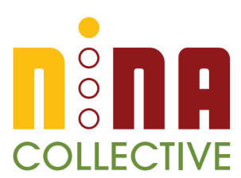

Demystifying Mentorship &
Mentoring with Purpose
with ananda mirilli

Participant: ______________

Mentorship Framework

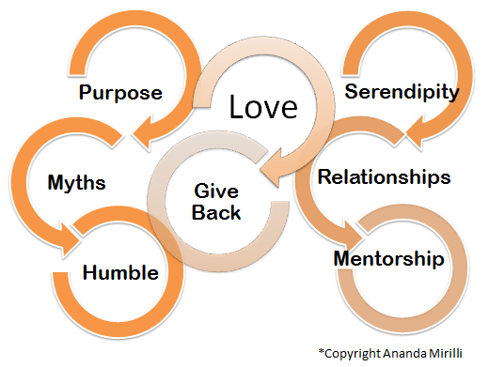

Love - Transformational Love that supports your purpose
Purpose - Enables you to intentionally focus based on what brings you joy and energy
Humble - Know that you are important as everyone and everything around you
Serendipity - Phenomenon event that comes to you when you are not expecting
Relationships - Connections with everyone and everything around you
Mentorship - Guidance to accomplish and define your purpose
Give Back - Human agreement to practice the gift of giving

Learning Tracker

Who am I? Describe the identities that comprise you (birthplace, race/ethnicity, social class, sexual orientation, gender, sexual identity, dis-abilities, spiritual beliefs, social class, education, professional background, relationships:

Finding your Purpose…
Dear present self:
I want to share with you what inspires me: ______________ and ______________ make me feel energized.
I feel that I am being my true self when I am doing ________________.
When I am really being my best self doing something that brings me joy, I am______.

- What struggle or sacrifice are you willing to tolerate?
- What is true about you today that would make your 8-year-old self cry?
- What makes you forget to eat and poop?
- How can you better embarrass yourself? When can you be vulnerable?
- How are you going to “save the world”?
- If you had to leave the house all day, everyday where would you go and what would you do?
- If you knew you had one year to give it a chance, what would you do, and how would you want to remember?*
Adapted from Mark Manson, 7 Strange Questions That Help You Find Your Life Purpose

Everybody needs a Mentor
What are the skills, knowledge and expertise you need in order to move towards your purpose?

Based on your purpose, what type of mentor(s) do you need?

Why are you seeking a mentor?
Based on your purpose, reflect on the reasons to seek mentorship.

How are you going to move towards your purpose?
Through mentorship you can…
… increase your social capital.
… stay focus on your purpose.
… have a thought partner to share accomplishments and overcome challenges.
… keep you motivated.

Decolonized mentorship can support...
- Career and professional development coaching
- Navigate organizational culture
- Recommendations and Collaborations
- Sexism, Racism, Homophobia and other “ism”s
- Microaggressions & Cultural Resilience
- Conflict Resilience
- Caring and Loving Self

Overcoming Challenges

What are the messages you believe to be true about mentorship?

What has prevented you from finding and or keeping a mentor? How are you planning to overcome past barriers?

MicroAggressions
Implicit or explicit insults and dismissals towards a member of a socially marginalized or underrepresented group.
Reflect on a time that you were impacted by or witness a microaggression:

Mentorship Myths may be preventing you to engage in mentorship
- I am uncomfortable asking...
- I am not an eligible mentee
- I don't’ have anything to give, I feel intimidated
- Everybody is busy, I am afraid of rejection
- I can’t find anyone perfect
- I don’t like networking, it takes to much time
- Formal relationship
- Mentorship is not fun!
Mentorship

Mentorship can and should be initiated by you and serve your purpose and needs. Before searching for your mentor make sure you flushed out your purpose/intentions and what type of mentorship you will need to move closer to fulfilling your desired purpose.
Mentors are everywhere!

When will serendipity happen and Where? Finding your mentors can take some time, I suggest that you start NOW. Who in your current sphere of influence you can ask? Who do you think know someone that could be your next mentor?

Write the name of three potential mentors:

1 - __________________ Phone/Email: ________________________
2 - __________________Phone/Email: ________________________
3 - __________________Phone/Email: ________________________
When are you calling and emailing them? (<10 days from today)
_______________________________
Where will you meet your next mentor?
_______________________________

Observations & Notes

Reflect on your identities as a place of strength and resilience. Who are you? What holds you and keeps you grounded? What sustains your heart?

Journal:

