**EVALUATION PANEL REPORT**

**Project**: Fire Station 6 Remodel and Addition

**Location**: 825 W Badger Road

**Aldermanic District**: 14

**RFP**: 8987-0-2021-AH

**Date**: 3/10/2021

This Evaluation has been reviewed and approved by a Principal Architect 2, Principal Engineer 2, Deputy City Engineer, Deputy Division Manager, or the City Engineer.  Yes  No

# Project Details

## Background Information

This project is for the remodel of Fire Station #6 located on Madison's south side at 825 West Badger Road, Madison, WI 53713. The goal of the project is to increase capacity at the existing location in anticipation of the Town of Madison annexation and to upgrade the facility to provide accommodations for a diverse workforce. The remodel will also incorporate operational and technological updates including mechanical upgrades and a redesign of living space for fire personnel to include separate gender facilities. Design is scheduled for 2021, with an intended construction start of early 2022.

## Role of Architecture and Engineering Services (A/E)

The full design scope includes the development and preparation of programming and conceptual plans, space designs, plans and specifications, preparation of bid documents, entitlement approval documents, assistance in the bid process, and construction and warranty phase administration for an addition to the apparatus bay for storage, site improvements to stormwater management (schematic design), remodel of second floor sleeping spaces/offices/locker rooms, remodel of entry area/kitchen, upgrades and/or replacement as applicable for all finishes, mechanical, electrical, plumbing, fire suppression, and technology systems throughout the facility.

The A/E design services for this contract shall include plans and specifications for site planning (as needed), landscaping, architectural design of interior and exterior spaces, finishes, MEP/FP/T (mechanical, electrical, plumbing, fire protection, and technology) systems design, construction specifications, and cost estimating.

# Purchasing Details

## Purchasing guidelines for RFP evaluation

The City of Madison solicited proposals from qualified vendors through a Request for Proposals (RFP) process. The RFP, addenda, tabulations, awards and related announcements were posted on two distribution networks – VendorNet and DemandStar – on Monday January 18, 2021. RFP respondents submitted questions about the RFP and Addendum 1 was issued on Friday February 5, 2021. RFP responses were due to Purchasing on Tuesday February 16, 2021.

Section B7. Evaluation Structure and Scoring (below) describes the process used to select a team.

## RFP Respondents

Firm A Bloom Companies

Firm B FGM Architects

Firm C InSite Consulting Architects (local vendor)

Firm D Martin Riley Architects

Firm E OPN Architects

Firm F Tactical Design North

Section 7. Evaluation Structure and Scoring (below) describes the process used to select a team.

## Disqualifications

No firms were disqualified.

## Evaluation Panel

The evaluation panel was comprised of 6 City Staff from 3 Departments: Fire, Engineering, and Building Inspection.

## Evaluation Structure and scoring

Evaluation for this RFP was conducted over two rounds. Upon completion of Round 1 (review of initial proposal), the top two respondents were invited to participate in Round 2 (an interview phase). Upon Completion of Round 2, a single Respondent was selected as the Panel’s recommendation. Evaluations were documented through a quantifiable scoring mechanism – see Section C of this document. Each round was conducted in a structured manner and administered by City Purchasing. See below for additional phasing details.

**Round 1** –Per instruction within the Request for Proposal, Respondents were asked to provide a series of deliverables, a portion of which were evaluated by the Panel. Evaluated deliverables include 3.3 Project Overview Qualifications and 3.4 Technical Qualifications. Panelists followed Purchasing guidelines and predetermined grading scales for each evaluated deliverable. Further, the following deliverables were given a score based on City Purchasing guidelines; 3.5 Cost and 3.2 Local Vendor Preference. Please note the RFP provided detailed instruction and grading scales to each evaluated deliverable.

Section C2 (below) shows the Round 1 scoring.

**Round 2** –Respondents were asked to deliver a presentation in an interview format. Interviews were conducted over Zoom (remote video and audio conferencing program) with each Respondent given a 1.0 hour slot. Respondents were provided a series of topics to address, and were responsible for the overall structure and flow of the interview. Panelists followed Purchasing guidelines and predetermined grading scales to evaluate the above stated topics.

Section C3 (below) shows the Round 2 scoring.

## Evaluation Timeline

Jan 18 – RFP is issued.

Feb 3 – Questions are due.

Feb 5 – Addendum to post answers is due.

Feb 16 – Response submissions are due.

Feb 17 – Distribute submissions to evaluation panel and first evaluation meeting.

Feb 23 – First round of scoring is due to City Purchasing.

Feb 24 – Score compilation is due and meeting with Purchasing to discuss Phase I score.

Feb 25 – Send out Phase II invitation for interview and presentation with 2 top scorers.

Mar 4 – Phase II interviews and presentations.

March 5 – Phase II score is due to Purchasing for compilation.

March 5 – Evaluation panel meets to discuss score and make a selection. Purchasing reviews selection.

March 8 – Communicate Intent to Award to the selected team.

March 9 – Results posted. Resolution to Common Council for introduction.

# Summary of Evaluation

## Recommendation

Firm E OPN Architects

Based on the scoring of the two rounds of evaluation, the selection team recommends that OPN Architects be approved as the consultant for the professional services required for the remodel and addition at Fire Station #6.

## Round 1 Scoring

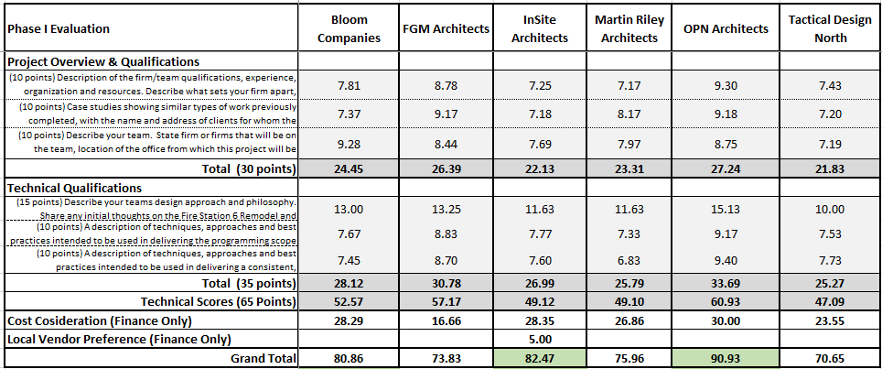

Notes:

1. Round 1 of the RFP proposal reviews is an opportunity to narrow down the field of candidates via an initial round of scoring (primarily based on response to the RFP guidelines in section 3).
2. A full description of requested material and grading weights can be found in this resolution’s associated RFP documents.
3. Green indicates the the top scoring respondents that were interviewed.

## Round 2 Scoring

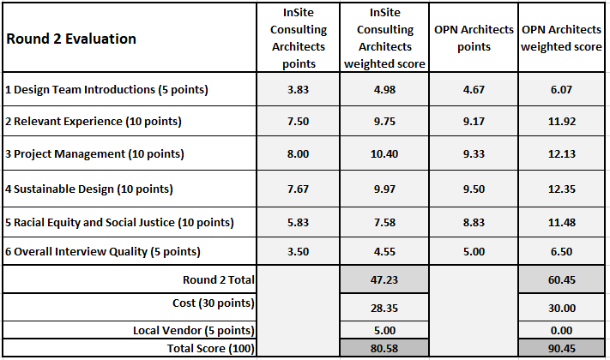

Notes:

1. The maximum points for each topic are shown in parenthesis. The Round 2 points were then weighted to a 65 point total to match the 65 points available in Round 1.
2. The Cost Score and Local Vendor points are then added to determine the Total Score.

## Fee Breakdown

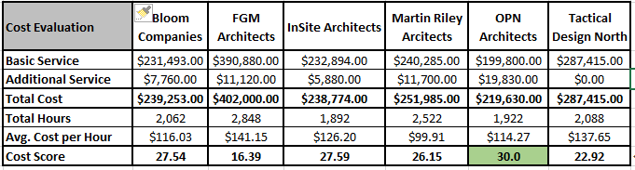

## Local Preference

The City of Madison has adopted a local preference purchasing policy granting a scoring preference to local suppliers. Only suppliers who meet the criteria and are registered as of the bid’s due date will receive preference. <www.cityofmadison.com/business/localPurchasing>

Was the outcome of this bid changed by the local purchasing ordinance?  Yes  No