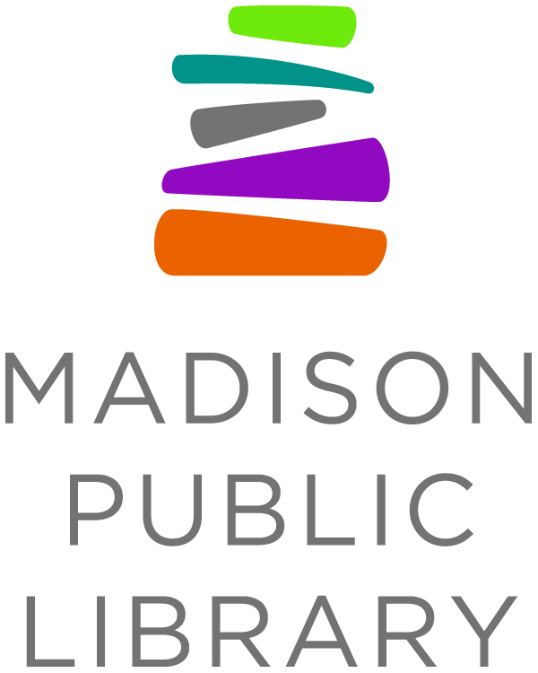
For Immediate Release: January 8, 2021
Library Contact: Rebecca Millerjohn, Youth Services Librarian with the Bubbler
Madison Public Library, 713-703-7881, rmillerjohn@madisonpubliclibrary.org

Madison Public Library, Forward Madison and The Flock Surprise Local 12-Year-Old Author Tikeh Tazeh

MADISON, WI - Madison Public Library recently added a new book to its shelves written by a local 12-year-old. The book, Hat Trick, is about a young man who moves to a new place and joins a soccer team. Its author, Tikeh Tazeh, is also a big soccer fan and, while soccer practices and games were on hold due to the pandemic, he decided to pursue his other passion of writing. The book quickly became a family affair, with Tikeh’s older brother Kiehmi helping to edit it, and his mother, Yvonne, helping get the word out.

“Tikeh wants to share his love for soccer and writing with other kids out there and hopefully be a source of motivation to them - despite the uncertainties that come along with the pandemic,” said Yvonne Tazeh in an email to the library. “Would you be interested in sharing his book with our community and possibly having it at the library?”

Once the library got in contact with the Tazeh family to let them know five copies of the book would be added to the collection, a handful of employees wanted to take things a step further by connecting Tikeh to Forward Madison FC. Rebecca Millerjohn and Rob Franklin reached out to their contact at The Flock, Grant Pieters, who helped bring in Forward’s new head coach Carl Craig and team captain Connor Tobin to celebrate with Tikeh.

“I wrote the book to encourage kids like me to use the talents they have to do great things,” said Tikeh. “Whether that’s playing soccer, dancing, playing an instrument or writing, make the most of that talent while you’re still a kid because when you’re an adult you’ll never forget it. Children can do extraordinary things and we have to show the world what we are capable of.”

The library, Flock and Forward Madison team worked with Conor Moran of the Wisconsin Book Festival to provide a surprise video chat with Tikeh and his family using the book festival’s Crowdcast platform. Unbeknownst to Tikeh, The Flock had sent a box of surprises that included t-shirts and soccer scarfs for him and Kiehmi. When talking to Tikeh via video chat, Pieters - a former junior high English teacher - encouraged Tikeh to continue following his passions.

“That is the key to anything, whether you are a player or a fan, soccer is about passion. And it really comes out in your book, both your passion for the written word and for the sport, as well,” said Pieters. “We absolutely had to celebrate your fine accomplishment at such a young age.”

Team captain for Forward Madison, Connor Tobin, was also impressed by Tikeh’s book.

“It’s not only about passion - you also combine that with ambition. There aren’t that many people at your age that are like, ‘I’m going to write a book.’ And we need more dreamers who set those lofty goals,” said Tobin.

The full video is available on Madison Public Library’s YouTube channel. Copies of Hat Trick are available from Madison Public Library now.

Related Links:
- Madison Public Library Surprised Young Author Tikeh Tazeh: https://youtu.be/E_jFfYSBJFE
- Impact Story from Madison Public Library: https://www.madisonpubliclibrary.org/impact/hattrick
- Place a hold on Hat Trick: https://mpl.linkcat.info/app/work/1489386
About Madison Public Library
Madison Public Library’s tradition of promoting education, literacy and community involvement has enriched the City of Madison for more than 145 years. Visit the library online at www.madisonpubliclibrary.org, madisonpubliclibrary on Facebook, @madisonlibrary on Twitter, or @madisonpubliclibrary on Instagram.
Other library services:
To inquire about or connect to library services, call the centralized telephone line (608-315-5151, 888-266-7805 toll free) 10 a.m.-6p.m. weekdays and 12-5 p.m. Saturdays. For more details, visit madpl.org/ask
More information
Curbside Pickup Page: madpl.org/curbside
Currently Available Library Services madpl.org/coronavirus
Madison Public Library’s Fine Free Page madpl.org/library-cards/fine-free
For a list of all library hours and locations, visit madpl.org/locations
For downloadable audiobooks and ebooks, visit madpl.org/ebooks
To get a library card, visit madpl.org/apply
For LINKcat online library catalog, visit https://www.linkcat.info

