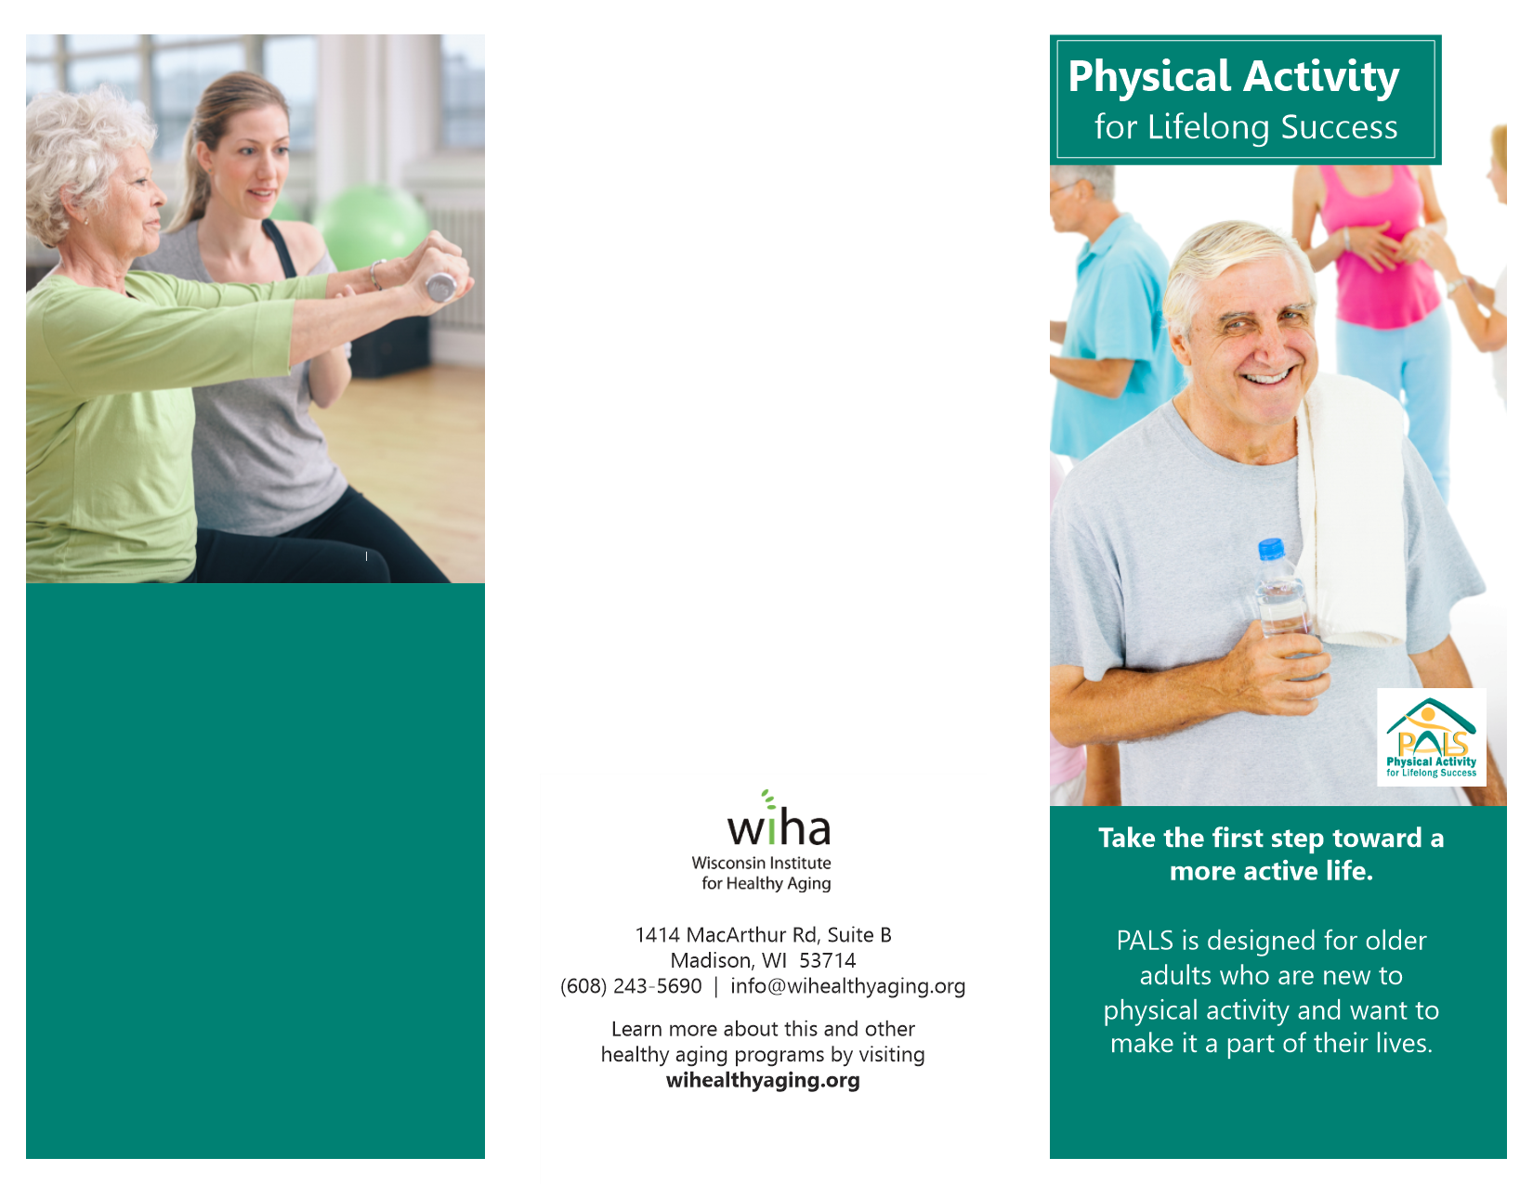

**Madison Senior Center**

**330 W Mifflin St, Madison, WI 53703**

**608-266-6581**

**March 9 – May 18**

**Monday – 9:30 – 10:30am**

**Tuesday – 9:30 – 11:15am**

**Thursday – 9:39 – 10:30am**

**Program is FREE but registration is required.**

**Call or email Laura Hunt for more information.**

**608-267-8650**

**lhunt@cityofmadison.com**

