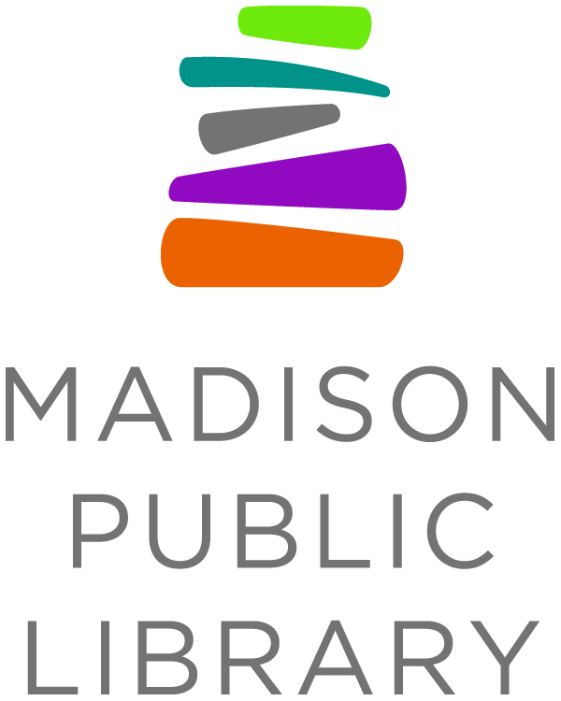

For Immediate Release: July 8, 2020
Media Contact: Hannah Peschek,
Madison Public Library, 608-243-0478, hpeschek@madisonpubliclibrary.org

Safely Give Blood at Madison Public Library this Summer

Madison Public Library’s Central Library has partnered with the American Red Cross to host two blood drives this summer. Only guests with scheduled appointments will be allowed into the building. We encourage masks, and the Red Cross will provide a mask if you don't have one. Donors can enter the Central Library building through the Fairchild Street doors.

Drive Details:
Site: Central Library
Address: 201 W. Mifflin St, Madison, WI, 53703
Room Name: Community Room 301
Date: Fri Jul 17, 2020
Time: 09:30 AM - 02:30 PM
Blood Program Leader Name: Hannah Peschek
Click here to make an appointment

Drive Details:
Site: Central Library
Address: 201 W. Mifflin St, Madison, WI, 53703
Room Name: Community Room 301
Date: Wed Aug 26, 2020
Time: 09:30 AM - 02:30 PM
Blood Program Leader Name: Hannah Peschek
Click here to make an appointment
Healthy individuals can still donate in areas that have issued shelter in place declarations or are operating under a phased reopening plan. The Red Cross follows the highest standards of safety and infection control, and volunteer donors are the only source of blood for those in need.

“You can still go out and give blood. We’re worried about potential blood shortages in the future. Social distancing does not have to mean social disengagement.” - U.S. Surgeon General
The American Red Cross recently began testing all blood, platelet and plasma donations for COVID-19 antibodies. The antibody test is authorized by the U.S. Food and Drug Administration (FDA) and will indicate if the donor’s immune system has produced antibodies to the coronavirus, regardless of whether they developed symptoms. This test is not to diagnose current COVID-19 symptoms, referred to as a diagnostic test. (Donors will receive results within 7-10 days)

About Madison Public Library
Madison Public Library’s tradition of promoting education, literacy and community involvement has enriched the City of Madison for more than 140 years. Visit the library online at www.madisonpubliclibrary.org, madisonpubliclibrary on Facebook, @madisonlibrary on Twitter, or @madisonpubliclibrary on Instagram.

