An Individual Development Plan (IDP) helps you:
- Assess your skills, interests, and values,
- Make a plan for achieving your personal and professional goals,
- Communicate with your supervisors/mentors about your evolving plan and needs.
There are many different ways to write an IDP, but the central concept is consistent: the IDP is a process through which you reflect, plan, and discuss in order to achieve personal and professional goals. The onus is on you to develop and maintain your IDP. And since it is your IDP, you choose which parts to share with your mentors and supervisors.
This document is one example of an IDP tool, endorsed by the City of Madison Human Resources. It includes step-by-step instructions, a self-assessment questionnaire, and forms for writing goals. Some departments and programs may use different instructions or templates so it is important to check you are using the right documents before starting this process.
You’ll want to revisit your IDP at least annually to update and refine it as your goals change or come into focus, and to record your progress and accomplishments.

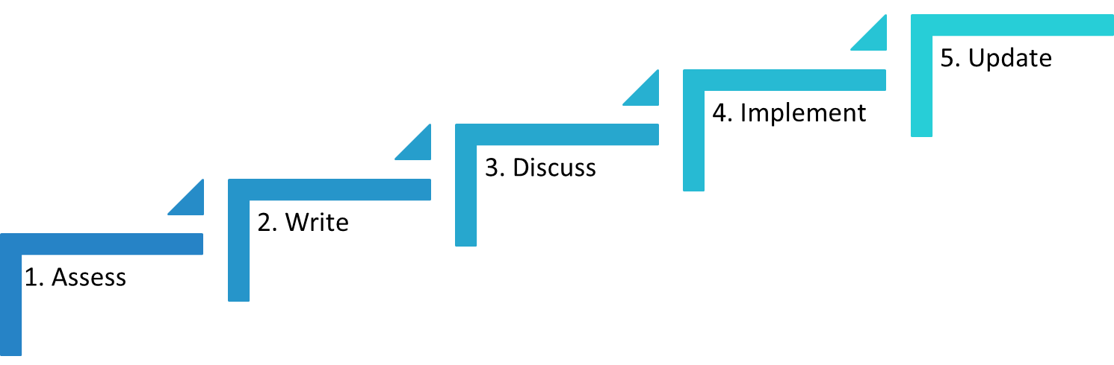

Basic Steps of the IDP
- Conduct a self-assessment.
- Write your Individual Development Plan.
- Discuss all or part of the IDP with your mentor.
- Implement the plan.
- Revise and update your IDP as needed.

Step 1: Conduct a self-assessment

Start the IDP process by taking some time to reflect on your skills.
Static self-assessment option (located in this document): On the upcoming pages, rate your confidence in your ability across nine areas of professional development.

Inquiry, Discovery, and Creation

Agency Expertise and Inter-Agency Connections

Leadership

Career Development

Managing Projects and People

Communication

Value for Diversity and Inclusion

Interpersonal Effectiveness

Personal Effectiveness

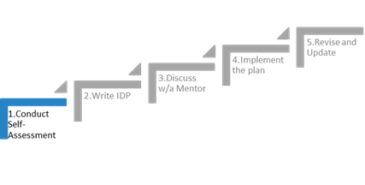
Instructions: Rate your confidence in your ability to do the following activities.
1 = very unconfident; 2 = somewhat unconfident; 3 = neither unconfident nor confident; 4 = somewhat confident; 5 = very confident
1. Inquiry, Discovery, and Creation
Inquiry, discovery, and creation describe characteristics of higher order thinking embodied by employees, including analyzing, evaluating, and creating.
 | 1 | 2 | 3 | 4 | 5
Create, invent, or update new and innovative concepts, processes, or services
Evaluate information, critique, and make judgments based on internal or external data/evidence
Pursue answers to complex questions
Think and act innovatively to create opportunities for change
Challenge conventional thinking
TOTAL

2. Agency Expertise and Inter-Agency Connections
Core to each employee’s work, agency-specific expertise and connections with other teams and agencies inform solutions to complex problems and creating new knowledge.
 | 1 | 2 | 3 | 4 | 5
Achieve the mission of my agency, as well as those defined for all City of Madison employees
Acquire depth and breadth of knowledge in my work unit
Develop advanced skills in my job
Work with peers and colleagues across the City of Madison and within my field
Embrace the values of my profession
Employ critical and analytical thinking and problem solving
Obtain support for special projects
Conduct myself ethically and professionally
Seek and utilize information and technology resources appropriate to my work
TOTAL
3. Leadership
Leadership occurs at all levels of successful organizations, regardless of formal authority or management role.
 | 1 | 2 | 3 | 4 | 5
Influence strategy and vision (e.g., on team projects)
Move ideas into action
Inspire others to new ways of thinking or acting
Foster creativity and innovation in people around me
Understand the dynamics of organizations
Be proactive and take risks
Acquire resources (e.g., get financial support from leadership, or collaborative support from others)
TOTAL

4. Career Development
Career development is a lifelong, proactive process of planning and implementation toward evolving, personally-defined career goals.
 | 1 | 2 | 3 | 4 | 5
Assess my skills, values, and interests
Obtain mentorship
Explore careers (e.g., seek career counseling, conduct informational interviews)
Market myself (e.g., utilize LinkedIn or other online platforms)
Interview for jobs successfully
Apply for job openings (e.g., writing a cover letter, resume, and/or CV)
Participate in professional groups or organizations, both within and outside the City of Madison
Build and communicate my transferable skills to potential employers
Take a lifelong approach to managing my career (e.g., utilizing an IDP, implementing both short- and long-term professional goals)
TOTAL
5. Managing Projects and People
Managing projects and developing people’s potential requires an understanding of systematic approach methods, evaluation, and effective use of resources.
 | 1 | 2 | 3 | 4 | 5
Manage projects effectively by setting goals and monitoring results
Lead, supervise and/or mentor others
Provide constructive feedback to others
Manage financial resources (e.g., reading and understanding budgets and the budgeting process)
Employ systems and technology to improve productivity
TOTAL

6. Communication
Communication is a bidirectional exchange of information, effective through understanding the intersection of media, audience, and message.
 | 1 | 2 | 3 | 4 | 5
Select and utilize the right media for a particular message (e.g., when to use written, oral, visual, digital, smart media)
Write or present information for “experts” in my agency
Write for a lay audience (i.e., those who are not experts in my agency)
Creatively engage with the public about my agency’s work
Write, support, or evaluate grant proposals or requests for proposals (RFPs)
Utilize effective technical writing skills for my agency when needed
Consult and listen well
TOTAL

7. Value for Diversity and Inclusion
True learning calls for free and open dialog, requires respect of all individuals and ideas, and prepares us to live and work in a world that speaks with many voices, from many backgrounds and experiences.
 | 1 | 2 | 3 | 4 | 5
Learn from and work effectively with people from cultural backgrounds different from my own (i.e., demonstrate cultural competence)
Learn from and work effectively with people from international backgrounds (i.e., demonstrate global competence)
Demonstrate equitable, inclusive leadership
Promote equitable, inclusive, and respectful workplaces
Cultivate relationships with people from different backgrounds, experiences, cultures
Recognize differences and similarities as they enhance and enrich experiences for all
TOTAL

8. Interpersonal Effectiveness
Interpersonal effectiveness entails recognizing and assessing the impact of one’s behavior on others, as well as understanding and cultivating positive relationships - e.g., with peers, coworkers, and managers.
 | 1 | 2 | 3 | 4 | 5
Form teams and collaborate
Appreciate, embrace, and/or foster the diverse perspectives of people around me
Network effectively with others in a professional setting
Negotiate (e.g., among people with conflicting ideas, salary negotiation)
Resolve conflict between people or groups
Mentor others (e.g.,new team members)
Help create a positive climate (i.e., a workplace where everyone feels comfortable and appreciated)
Work effectively with my supervisor, mentor, and/or City leadership
TOTAL

9. Personal effectiveness
Personal effectiveness describes a set of attitudes and attributes that are needed for lifelong career success.
 | 1 | 2 | 3 | 4 | 5
Maintain an openness to new ideas and perspectives
Cultivate an attitude of curiosity and joy of discovery
Stay motivated
Demonstrate resilience
Demonstrate integrity
Think introspectively
Engage in activities that improve conditions for others or help shape the future of my community (i.e., civic engagement)
Be healthy physically, emotionally, and financially
Manage my time effectively
Stay organized in my personal and work responsibilities
TOTAL

Interpreting Your Responses to the Self-Assessment
Take a moment to consider your responses from Step 1. Note subareas where you feel most confident (rated 4 or 5) and least confident (rated 1 or 2). Circle any to which you feel committed to developing; these will be used in the goal-setting exercises later in the workbook.
 | 1 | 2 | 3 | 4 | 5
TOTALS

QUALITATIVE

Self-Assessment, Part 1

Defining success and developing the skills, knowledge, and attitudes to get there.

- Where would you like to be in the next 5 years? What type of work? What are the core feelings you want to experience during a typical day of work?

- What competencies are required for that line of work?

- How well do your current skills match the competencies required for your chosen career?

- Are there particular technical skills or agency-specific knowledge that you need to develop? How does that fit into your career path/plan?

- Are there specific work activities you would like to accomplish or work toward during the next year? Two years? (Examples: join a professional organization, take on a new task, participate on a committee…) What support might you need?

- What are your short-term goals related to career exploration? (Examples: learn about writing, conduct informational interviews, find out where graduates in my field are working/finding careers, learn where people with my skills are working…)

- How will you develop contacts--a network--related to your career exploration goals?
- Comments:

Selected Resources:
Desire Map: https://www.thedesiremap.com/
Forbes article on goal-setting in organizations: https://www.forbes.com/sites/markmurphy/2015/01/16/passion-is-the-missing-ingredient-in-goal-setting/#4bcacf261017
VIA Survey: http://www.viacharacter.org/www/Character-Strengths-Survey#
Clifton StrengthsFinder 2.0: City of Madison and Madison Public Library have hard copy books available
High 5 (a free strengths test): https://high5test.com/
Ikigai ( a great article with some background and practical steps for getting started): the-japanese-concept-ikigai-is-a-formula-for-happiness-and-meaning-8e497e5afa99
Meyer, Paul J (2003). "What would you do if you knew you couldn’t fail? Creating S.M.A.R.T.E. Goals". Attitude Is Everything: If You Want to Succeed Above and Beyond. Meyer Resource Group, Incorporated.

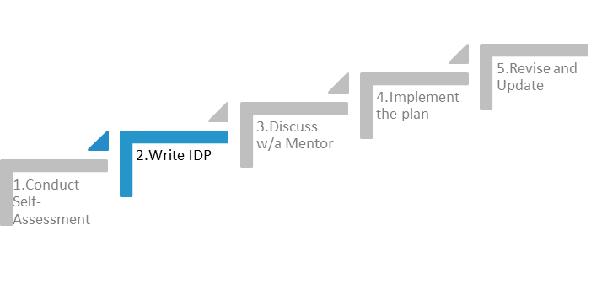

STEP 2: Write the IDP
The IDP helps you map out the general path you want to take toward achieving your goals. The goals you include in your IDP are based on the strengths and weakness that you identified in Step 1, together with the milestone activities that mark successful progress through your employee journey (e.g., completing your probationary period, promotions, new assignments), plus any other specific skills and knowledge needed to prepare for your career.
Use the table on the following pages as a starting point. You can expand and modify it to fit your own list of goals and strategies. For example, some mentees have transferred and expanded the table into an Excel spreadsheet to track multiple evolving goals over time.
And remember, your IDP is a living document that will and should be updated and changed as often as necessary.

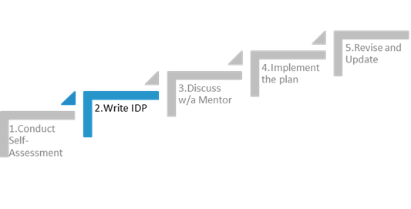

QUANTITATIVE Self-Assessment Summary
In reviewing the numerical data, be sure to jot down the specific question topics in the list below. Which of the topics would energize you? Which would be a total drain on your energy and time? Use those to help you highlight the most important overall 3-5 to focus on.
Topics from Confident (4’s and 5’s) Categories | Topics from the Unconfident (1’s and 2’s) Categories

QUALITATIVE Self-Assessment Summary
Define approaches and strategies below, and include a timeframe for beginning and completing these actions. Make sure to have an outcome statement that is clear enough to allow someone (including you!) to know if you’ve met your objective.
Skills, Knowledge, or Attitudes to be Learned | Approaches and Strategies | Timeframe | Outcomes

Goal Prioritization
 | Near Term (within the next 6 months) | Long Term (more than 6 months away)

High Impact

Low Impact

Creating S.M.A.R.T.E. Goals
One thing that is very important when setting S.M.A.R.T.E. goals, is formulating them POSITIVELY. Remember that what you focus on increases!

S.M.A.R.T.E. goal setting: Specific
What exactly do you want to achieve? The more specific your description, the bigger the chance you'll get exactly that. S.M.A.R.T.E. goal setting clarifies the difference between 'I want to be a millionaire' and 'I want to make $50,000 a month for the next ten years by creating a new software product'.
Questions you may ask yourself when setting your goals and objectives are:
- What exactly do I want to achieve?
- Where?
- How?
- When?
- With whom?
- What are the conditions and limitations?
- Why exactly do I want to reach this goal? What are possible alternative ways of achieving the same?

S.M.A.R.T.E. goal setting: Measurable
Measurable goals means that you identify exactly what it is you will see, hear and feel when you reach your goal. It means breaking your goal down into measurable elements. You'll need concrete evidence. Being healthier is not evidence; not smoking anymore because you adhere to a healthy lifestyle where you eat vegetables twice a day and get in 10000 steps daily is.
Measurable goals can go a long way in refining what exactly it is that you want, too. Defining the physical manifestations of your goal or objective makes it clearer, and easier to reach.

S.M.A.R.T.E. goal setting: Attainable
Is your goal attainable? That means investigating whether the goal really is acceptable to you. You weigh the effort, time and other costs your goal will take against the profits and the other obligations and priorities you have in life.
If you don't have the time, money or talent to reach a certain goal you'll certainly fail and be miserable. That doesn't mean that you can't take something that seems impossible and make it happen by planning S.M.A.R.T.E.ly and going for it!

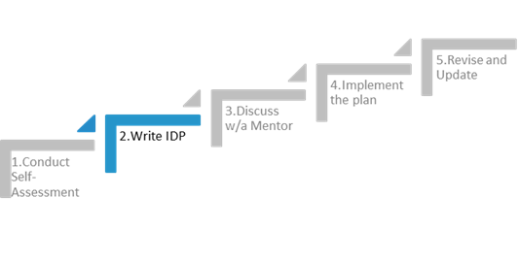

There's nothing wrong with shooting for the stars; if you aim to make your department twice as efficient this year as it was last year with no extra labor involved, how bad is it when you only reach 1.8 times? Not too bad...

S.M.A.R.T.E. goal setting: Relevant
Is reaching your goal relevant to you? Do you actually want to run a multinational, be famous, have three children and a busy job? You decide for yourself whether you have the personality for it, or your team has the bandwidth.
If you're lacking certain skills, you can attend trainings, read books and articles, and job shadow. If you lack certain resources, you can look for ways of getting them.
The main questions, why do you want to reach this goal? What is the objective behind the goal, and will this goal really achieve that?
You could think that having a bigger team will make it perform better, but will it really?

S.M.A.R.T.E. goal setting: Timely
Time is money! Make a tentative plan of everything you do. Everybody knows that deadlines are what makes most people switch to action. So install deadlines, for yourself and your team, and go after them. Keep the timeline realistic and flexible, that way you can keep morale high. Being too stringent on the timely aspect of your goal setting can have the perverse effect of making the learning path of achieving your goals and objectives into a hellish race against time – which is most likely not how you want to achieve anything.

S.M.A.R.T.E. goal setting: Equitable
Madison is known for its commitment to livability and sustainability, yet not all people, families and neighborhoods share in this experience. Local data show that people of color, people with disabilities and people from low-income backgrounds fare far worse than many other city residents in areas like educational attainment, income, health outcomes and housing affordability and quality. Our focus on racial equity will allow us to address Madison’s most persistent inequities while supporting a sustained shift towards fairer practices throughout our institutions that will ultimately benefit all. Are your goals aligned with the City’s commitment to a just and equitable workplace?

GENERIC GOAL 1:
Specific | Measurable | Attainable | Realistic | Timely | Equitable

S.M.A.R.T.E. GOAL 1:

GENERIC GOAL 2:
Specific | Measurable | Attainable | Realistic | Timely | Equitable

S.M.A.R.T.E. GOAL 2:

GENERIC GOAL 3:
Specific | Measurable | Attainable | Realistic | Timely | Equitable

S.M.A.R.T.E. GOAL 3:

GENERIC GOAL 4:
Specific | Measurable | Attainable | Realistic | Timely | Equitable

S.M.A.R.T.E. GOAL 4:

GENERIC GOAL 5:
Specific | Measurable | Attainable | Realistic | Timely | Equitable

S.M.A.R.T.E. GOAL 5:

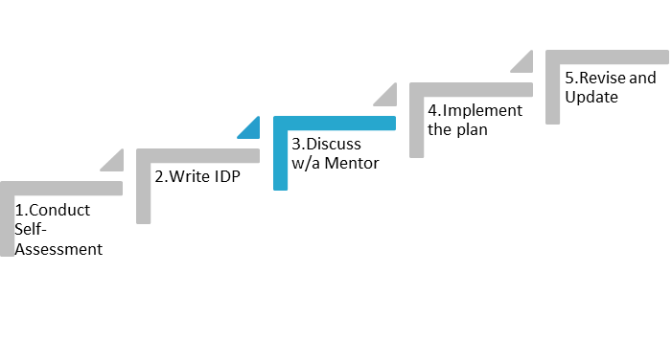

STEP 3: Discuss with Supervisor, Mentor, or Friend
Discussing what you discovered from your skills assessment, and talking about your career goals and interests with your mentor or supervisor might help you identify developmental needs and areas to work on. By helping you compare current skills and strengths with those needed to achieve your career objectives, your mentor or supervisor can be an important ally.
Some might feel it’s risky to share, for example, their weaknesses or their interest in a career outside the City of Madison with their supervisor and/or mentor. While it’s not necessary to share all results right away, consider how the feedback from your mentor or supervisor might support your plan, and provide insights and resource ideas.
It is strongly recommended that you discuss your plan with your primary mentor or supervisor but also be creative about whom you approach for advice. You can get useful feedback from multiple people with a broad range of experiences and perspectives including friends, family, and colleagues other than your primary mentor or supervisor.
- List the steps you have already taken to establish career goals, and review whether they are they realistic given your skills, aptitude, and realistic given your skills, aptitude, and how your employer defines an “ideal employee.” This step requires total honesty.
- Review your last one-on-one discussion points to see how you are currently doing. This requires some critical assessment of yourself.
- Were there any improvements required since the last performance progress meeting, and if so, how has your work been?
- Consider how long you have been performing at your current level in months or years.
- Evaluate how you have responded to work requests and suggestions your boss has made.
- Build a list of questions to ask your manager – what do you want to learn about as a result of meeting with him or her?
- Investigate the tools that the City of Madison provides to help you develop in your career, such as offering training.
- Identify the things you’d like to do in your current job that would stretch you.
- Are there other responsibilities at work you could take on?
- Provide an agenda (a list of points you want to discuss with your manager). An agenda will allow both you and your manager to think about the topic in advance.
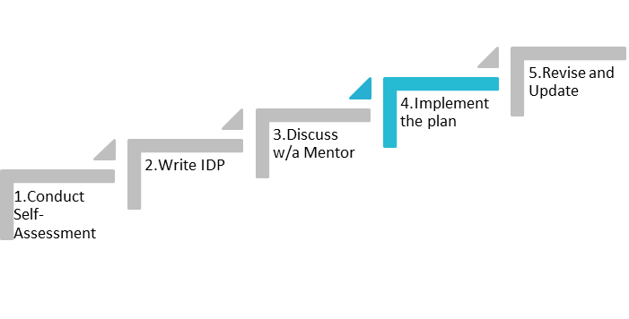

STEP 4: Implement the Plan
Put your plan into action. Stay organized and seek out the support you need to stay on track. Commit to the plan, but also remember that you will need to be flexible and modify your plan as your goals or circumstances change. Keep your IDP in a convenient place and check it often. Add your IDP deadlines to your calendar to integrate them with deadlines for other work and personal events.
Checklist of SMARTE Goals
Now-6 months |  | 6-12 Months |  | Beyond 12 Months
My first step will be:
My accountability partner will be:
I will ask them for support by saying:
I will review my progress on the following date:

How can you make your IDP a priority throughout the year?

What are the specific action steps that you can accomplish . . .
A.) Today?
B) Before the end of the month?
C) In 30, 60, 90 days?
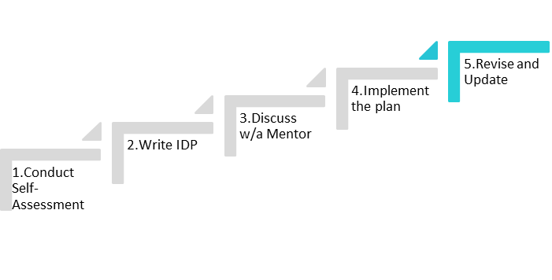

STEP 5: Review and Revise Your IDP
Review the IDP with your mentor or supervisor on a regular basis (on a schedule decided upon together) and revise/update. At a minimum, you should revisit and discuss your IDP with your mentor or supervisor annually.
And, importantly, celebrate your achievements!

Adapted from:
Federation of American Societies of Experimental Biology (FASEB) IDP for Postdoctoral Fellows: faseb.org/portals/2/pdfs/opa/idp.pdf
myIDP website: myidp.sciencecareers.org
Individual Development Plan for UCSF Faculty
Individual Development Plan for Case Western Reserve University Postdoctoral Trainees postdoc.case.edu/current/careers.html
The National Postdoctoral Association Postdoctoral Core Competencies: www.nationalpostdoc.org/competencies
University of Wisconsin-Madison Graduate School Office of Professional Development, DiscoverPD: my.grad.wisc.edu/DiscoverPD

Notes:

