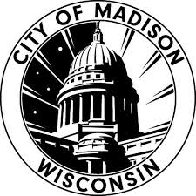

#TEAMCITY

TEAM NOMINATION FORM

Nominations are now being accepted for City of Madison’s #TeamCity team recognition! Submissions are accepted on a rolling basis. This is Our Madison: Inclusive, Innovative & Thriving. Team awards are designed to recognize the outstanding work of groups working in tandem toward a common goal to advance our city. Teams may be formal or informal, but must have worked together on defined projects. Any City employee may nominate a team.

We value equity; civic engagement; environmental sustainability; well-being; shared prosperity and stewardship. We are on a mission to provide the highest quality of service to our residents and visitors.

Please use this form to tell us the story of this outstanding team’s accomplishments for the City of Madison.

Please submit this nomination, or questions, to iuludag@cityofmadison.com or mail the form through inter-departmental mail to Ilknur Uludag at Fleet (4151 Nakoosa Trail).

We will reach out if the nominated team is selected, and provide ceremony details.

***

Your Name & Title: Click or tap here to enter text.

Team and Team Members: Click or tap here to enter text.

Project deliverables or team’s responsibility:
Click or tap here to enter text.

Why should this team receive the award?
Click or tap here to enter text.

Any other supporting information (optional):
Click or tap here to enter text.

